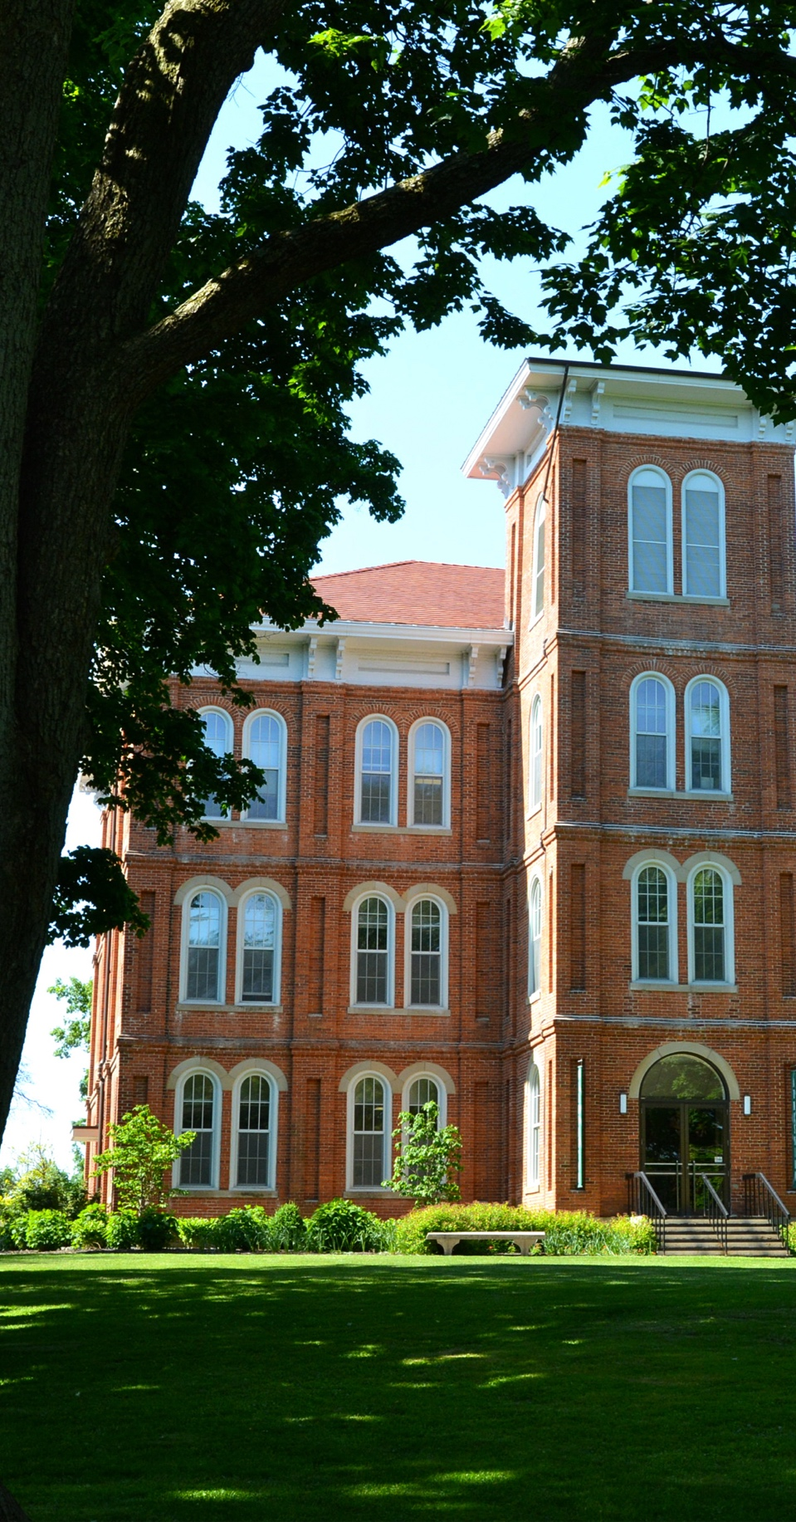

REPLACE PICTURE WITH

YOUR OWN PHOTO

* Set behind text
* Crop as needed

Additional Information

Header (Museo 700)

Subhead (Museo 500)

Content (Cantarell)